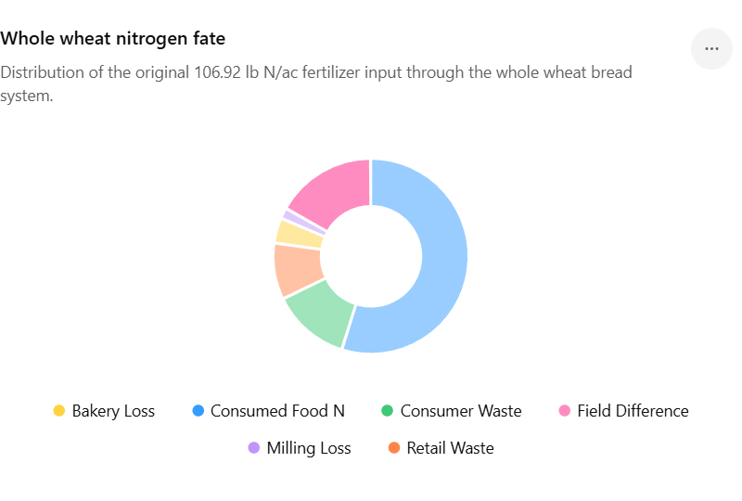
Destination Nitrogen
Consumed Food N 59.05
Consumer Waste 13.85
Retail Waste 9.94
Bakery Loss 4.36
Milling Loss 1.79
Field Difference 17.93

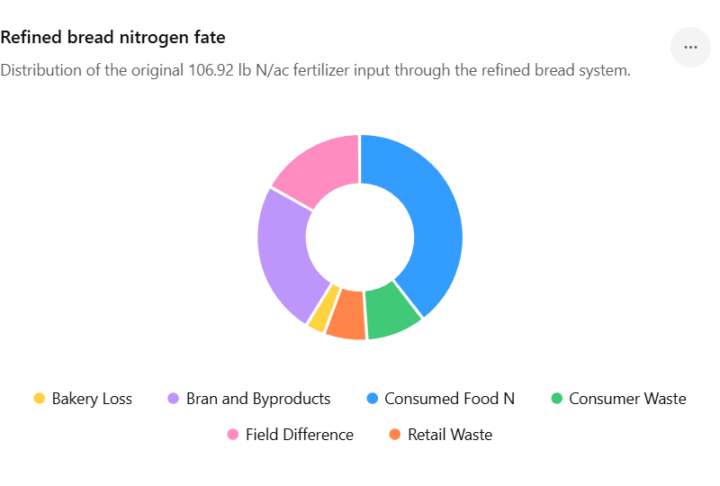
Destination Nitrogen
Consumed Food N 42.53
Consumer Waste 9.98
Retail Waste 7.16
Bakery Loss 3.14
Bran and Byproducts 26.19
Field Difference 17.93

